**Complejidad Temporal**

1. Método para formar cola:

n=building.size()

j=tp-1

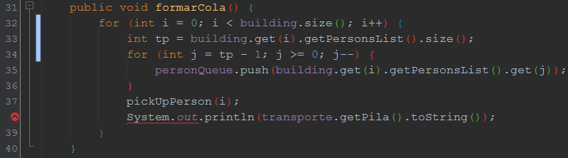

Función: $f\left(x\right)=\left[4n+2\left(n+j\left(n\right)\right)\right]+2$

|  |  |
| --- | --- |
| LINEA | CANTIDAD DE VECES QUE SE REPITE |
| 32 | n+1 |
| 33 | n |
| 34 | n+j(n) +1 |
| 35 | n+j(n) $+$ |
| 37 | n |
| 38 | n |

1. Método crear persona:

n=floors

j=officesPerFloor

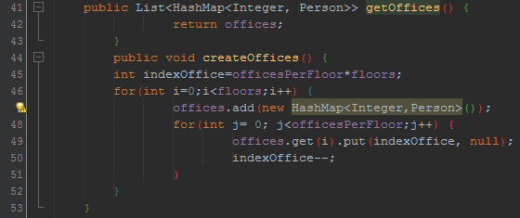

Función: $f\left(x\right)=n+3\left(n+j\left(n\right)\right)+3$

|  |  |
| --- | --- |
| LINEA | CANTIDAD DE VECES QUE SE REPITE |
| 45 | 1 |
| 46 | n+1 |
| 47 | n |
| 48 | n+j(n) +1 |
| 49 | n+j(n) |
| 50 | n+j(n) |